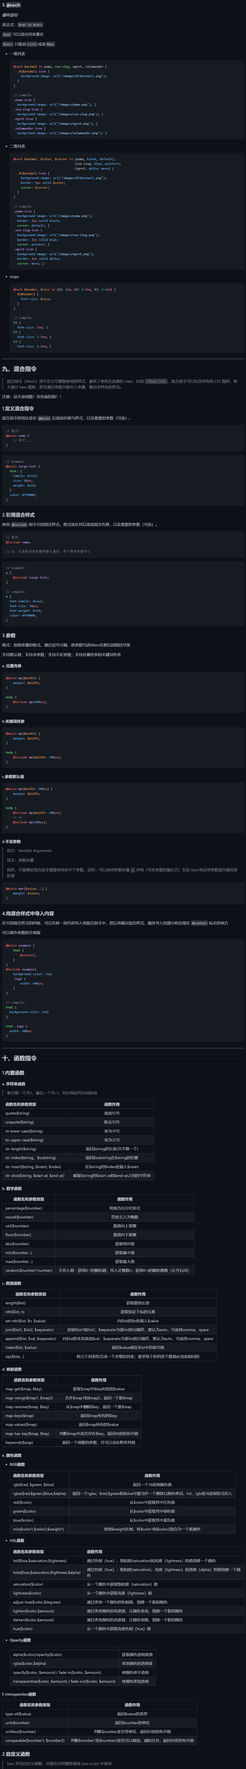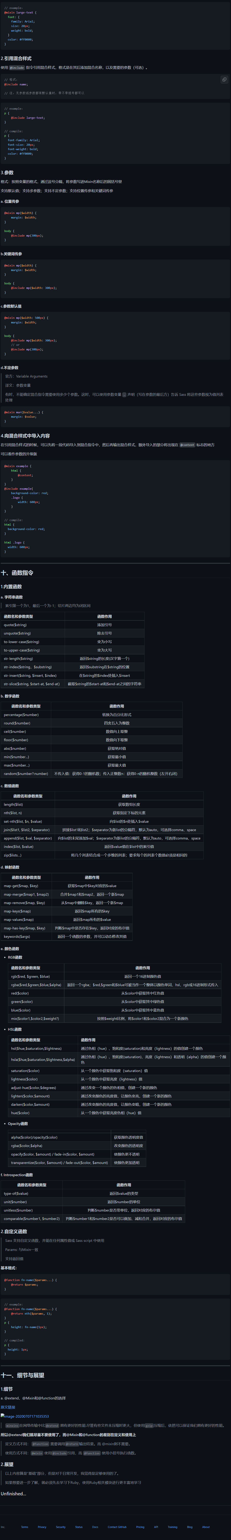

链接：<https://github.com/ggdream/scss/blob/master/3%E3%80%81SassScript.md>